| **EXP:2**  **30/01/2025** | **VISUALIZING TIME SERIES DATA** |
| --- | --- |

**AIM:**

To Implement programs for visualizing time series data

**PROCEDURE:**

1. **Bar Plot**

**import pandas as pd**

**import matplotlib.pyplot as plt**

**import seaborn as sns**

**# Load the dataset**

**file_path = "monthly-beer.csv"**

**df = pd.read_csv(file_path)**

**# Convert 'Month' to datetime for proper plotting**

**df["Month"] = pd.to_datetime(df["Month"])**

**# Set plot style**

**sns.set_theme(style="darkgrid")**

**# Create figure**

**plt.figure(figsize=(10, 6))**

**plt.title("Bar Plot: Yearly Beer Production")**

**# Bar plot**

**sns.barplot(x=df["Month"].dt.year, y=df["Monthly beer production"], ci=None)**

**plt.xlabel("Year")**

**plt.ylabel("Beer Production")**

**plt.xticks(rotation=45)**

**plt.show()**

**2)Line Plot**

**import pandas as pd**

**import matplotlib.pyplot as plt**

**import seaborn as sns**

**# Load the dataset**

**file_path = "monthly-beer.csv"**

**df = pd.read_csv(file_path)**

**# Convert 'Month' to datetime for proper plotting**

**df["Month"] = pd.to_datetime(df["Month"])**

**# Set plot style**

**sns.set_theme(style="darkgrid")**

**# Create figure**

**plt.figure(figsize=(10, 6))**

**plt.title("Line Plot: Monthly Beer Production Over Time")**

**# Line plot**

**sns.lineplot(x=df["Month"], y=df["Monthly beer production"])**

**plt.xlabel("Month")**

**plt.ylabel("Beer Production")**

**plt.xticks(rotation=45)**

**plt.show()**

**3)Scatter Plot**

**import pandas as pd**

**import matplotlib.pyplot as plt**

**import seaborn as sns**

**# Load the dataset**

**file_path = "monthly-beer.csv"**

**df = pd.read_csv(file_path)**

**# Convert 'Month' to datetime for proper plotting**

**df["Month"] = pd.to_datetime(df["Month"])**

**# Set plot style**

**sns.set_theme(style="darkgrid")**

**# Create figure**

**plt.figure(figsize=(10, 6))**

**plt.title("Scatter Plot: Monthly Beer Production Over Time")**

**# Scatter plot**

**sns.scatterplot(x=df["Month"], y=df["Monthly beer production"])**

**plt.xlabel("Month")**

**plt.ylabel("Beer Production")**

**plt.xticks(rotation=45)**

**plt.show()**

**4)Histogram Plot**

**import pandas as pd**

**import matplotlib.pyplot as plt**

**import seaborn as sns**

**# Load the dataset**

**file_path = "monthly-beer.csv"**

**df = pd.read_csv(file_path)**

**# Convert 'Month' to datetime for proper plotting**

**df["Month"] = pd.to_datetime(df["Month"])**

**# Set plot style**

**sns.set_theme(style="darkgrid")**

**# Create figure**

**plt.figure(figsize=(10, 6))**

**plt.title("Histogram: Distribution of Monthly Beer Production")**

**# Histogram**

**sns.histplot(df["Monthly beer production"], bins=20, kde=True)**

**plt.xlabel("Beer Production")**

**plt.ylabel("Frequency")**

**plt.show()**

**5)Box Plot**

**import pandas as pd**

**import matplotlib.pyplot as plt**

**import seaborn as sns**

**# Load the dataset**

**file_path = "monthly-beer.csv"**

**df = pd.read_csv(file_path)**

**# Convert 'Month' to datetime for proper plotting**

**df["Month"] = pd.to_datetime(df["Month"])**

**# Set plot style**

**sns.set_theme(style="darkgrid")**

**# Create figure**

**plt.figure(figsize=(10, 6))**

**plt.title("Box Plot: Distribution of Monthly Beer Production")**

**# Box plot**

**sns.boxplot(y=df["Monthly beer production"])**

**plt.ylabel("Beer Production")**

**plt.show()**

**OUTPUT:**

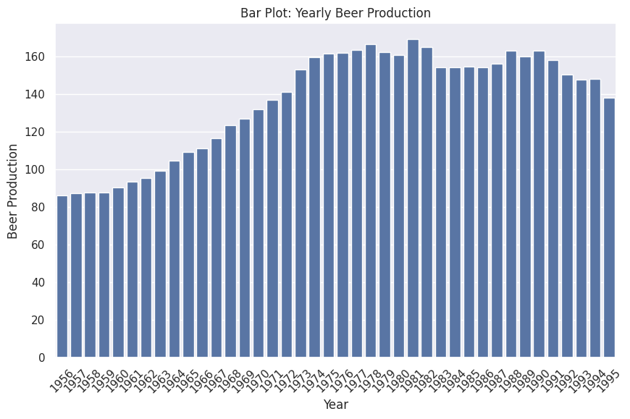

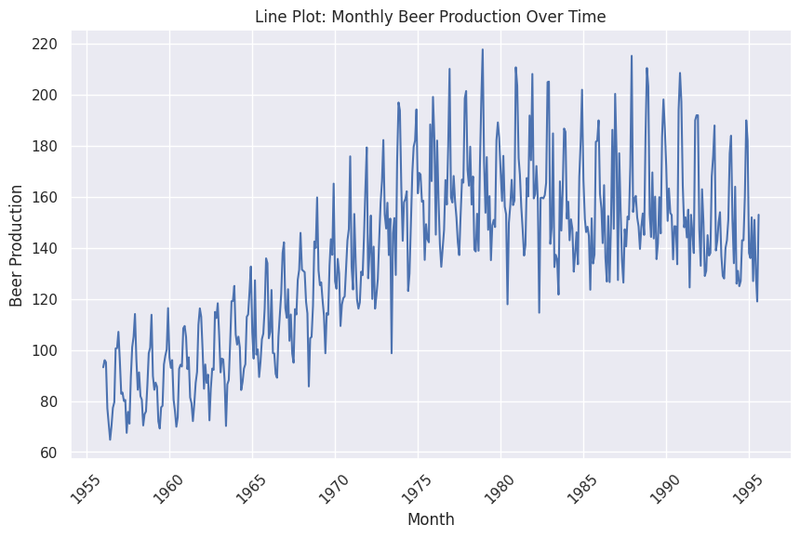

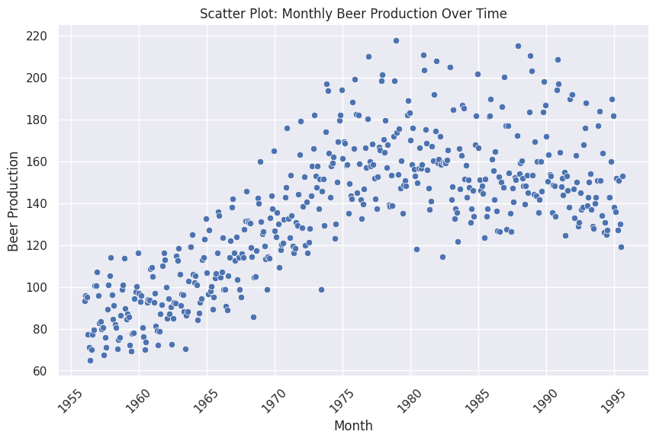

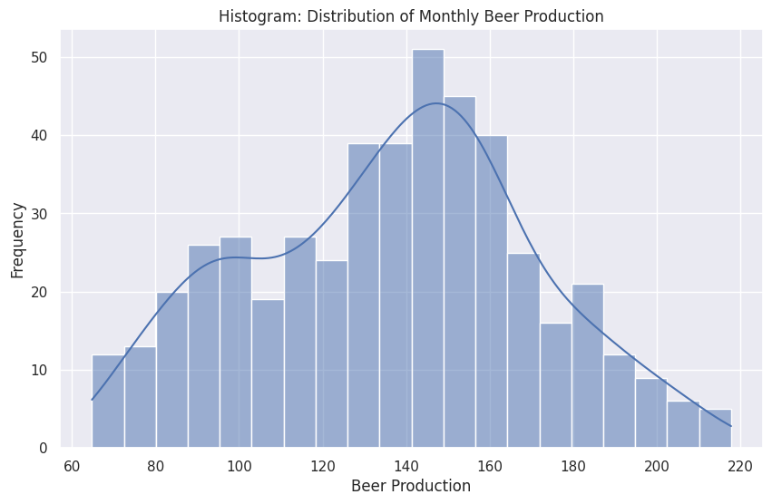

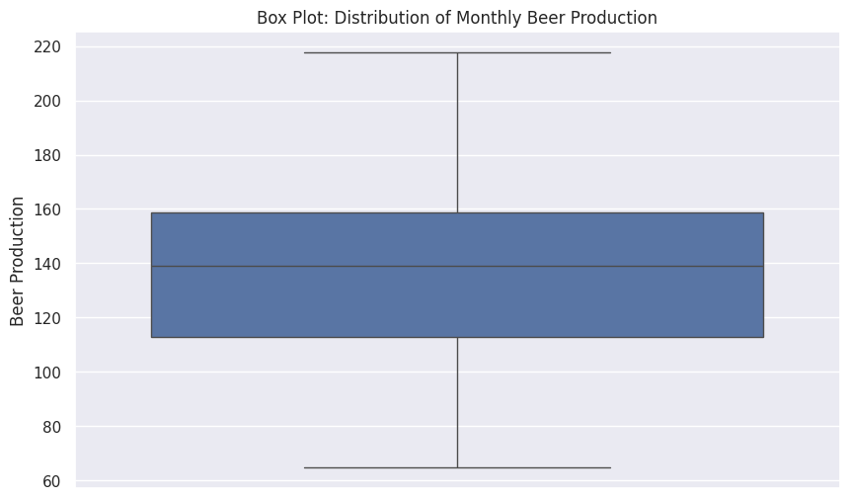

**RESULT:**

Thus the program has been executed successfully.